Potassium Perchlorate
Potassium Perchlorate has no known hydrates and is not hygroscopic.
Potassium Perchlorate is usually made by double decomposition of KCl and Sodium Perchlorate. The Potassium Perchlorate is not very soluble and will ppt out immediately as a very fine crystalline product (your solution will look like yougart if you add the KCl quickly) as soon as you add the KCl to the Sodium Perchlorate. If you are using Sodium Perchlorate solution from a cell there will be some Sodium Chlorate present in the electrolyte and it should be borne in mind that you will get some Chlorate contamination of your product. A Perchlorate product that is contaminated with Chlorate should be treated the same as if you had Chlorate when it comes to mixing with sulphur or other combustibles that are dangerous with Chlorate. If you want pure K Perchlorate you must destroy all of the Sodium Chlorate present in the Sodium Perchlorate by chemical means and then use the pure Sodium Perchlorate to make Potassium Perchlorate. You may be able to clean it up by recrystallization but it is a laborious task. You can check for the presence of Chlorate by using a sensitive test or use an excess of chemicals to by sure that all Chlorate is gone.
See Destroying Chlorate by chemical means
The solutions of NaClO4 and KCl should be neutral for the following. If they are not you should neutralise them by adding a small amount of KOH or NaOH. If you don't do this small traces of acid are introduced into the final product which is very dangerous.
You can also make Potassium Perchlorate by decomposition of K Chlorate, it is quite a good way to make the stuff and AFSIK it will not be contaminated with K Chlorate so long as you heat to the correct temperature. The KCl (byproduct) will be fairly easy to get out of the Perchlorate. See Wouters page.
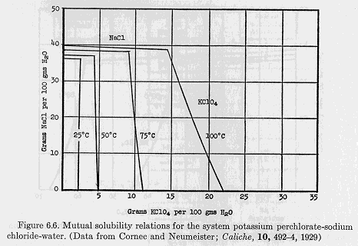
Potassium Perchlorate can also be made by electrolyzing Potassium Chlorate in a similar manner to that used for Sodium Chlorate. The solubility of Potassium Chlorate is low and the concentration of Chlorate in the cell will be low and you will have to use large volumes of solution if you want large weights of product. You will also get lower current efficiency, the Perchlorate will ppt out as it is formed and may even encrust the anode. You will have to be careful and make sure that your finished product has all Chlorate removed. There is not much information regarding the manufacture of K Perchlorate via electrosynthesis in the literature. Some have suggested that it is erosive on lead dioxide anodes but this is not confirmed.
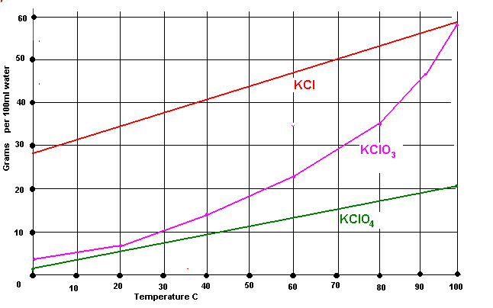
Some useful data
 | KCl | KClO4 | NaCl | NaClO4
Molecular weight | 74.5 | 138.5 | 58.5 | 122.5
Other compounds may be used instead of KCl, for example K sulphate and K Nitrate but if you use the Chloride the by product is NaCl which can be fed back into the recrystallizing stage. It is better to feed back this solution to the recrystalization stage as opposed to the Sodium Chlorate cell. If you feed it back to the cell you may get K Chlorate being precipitated and it is hard to clean up the K Chlorate from cell discolourents. It is not critical though.
HIT THE BACK BUTTON ON YOUR BROWSER

