Potassium Chlorate
Potassium Chlorate is not hygroscopic and has no known hydrates.
Potassium Chlorate can be made similarly to Sodium Chlorate. Since Potassium Chlorate is much less soluble than Na Chlorate the K Chlorate will crystallise out of the cell electrolyte as you run the cell. This can be handy or troublesome depending on how clean a product you want. If you are using carbons as anodes the graphite will be impossible to separate out of the solid product and you will have to re dissolve it in order to filter out the graphite. If using lead dioxide there will be a small amount of brown lead dioxide on the bottom of the cell with the solid Chlorate and if you wish to remove it you will have to re dissolve the Chlorate and filter. This will take alot of water as the K Chlorate is not very soluble and if you try to use hot water you will get the K Chlorate crystallising out in the filter.
Potassium Chlorate is by far the most popular Chlorate for the amateur to make and is also the easiest. If you keep your cell clean, use a DSA anode and a non corroding anode (proper type of SS or Ti) you will be able to harvest almost pure K Chlorte from your cell at regular intervals. It will be good to give it a wash using cold water to get rid of any KCl that may be in the wet product. You should then return the washings to the cell so that nothing is wasted.
KCl can be obtained as a fertilizer, it is called Muriate of Potash. It will have 50% (approx) K written on the bag or in the states where % K is given in a different way it will have a different figure.
Another possible source of KCl is with the people who sell equipment for softening water. Sodium Chloride is usually used in theses devices but some people object to haveing any Sodium ion in their drinking water so they need to use Potassium Chloride instead, so you may be able to get a bag of Potassium Chloride in the same place as where they supply the NaCl for the water solteners

Run time
You should start off your K cell with about 420g of K Chloride per litre of water. This will require some heating of the water. When running the cell you may add water or KCl solution to top it up. A similar modification, as per the Na cell, should be made to the run time of the K cell if you are using KCl solution to top up the cell.
The run time for a K Chlorate cell can be calculated by simply dividing the figure's in the table (in the run time section for Na Chlorate) by 1.27 and using the resulting figure as per usual in the formula, or use the program.
At the end of the run you will have a ppt of Chlorate on the bottom of the cell.
Remove the Chlorate, and add 0.61 grams KCl for every gram K Chlorate removed from cell and top up with water if necessary. You will now be back (approx.) to the conditions at the start of the run. The run time will be the same as it was the first time. You will probably have to recrystalize your crop of K Chlorate to clean it up from lead dioxide or graphite. If using DSA and a non corroding cathode you can use after a small wash.

Potassium Chlorate from Sodium Chlorate
Potassium Chlorate can also be made by adding KCl solution to Sodium Chlorate solution (so called double decomposition). The Potassium Chlorate will ppt out as it is the least soluble of all the components in the solution.
If you make Sodium Chlorate first and then make Potassium Chlorate by adding KCl, you can get rid of the lead dioxide powder by letting the Sodium Chlorate cell settle for a day and then decanting off the Sodium Chlorate. This saves you the bother of filtering. You could probably get rid of the graphite by the same method (if you are using a graphite anode) but you would have to let the cell settle for more than a day and the decanting would have to be done carefully. When the decanting is done you will have a clear liquid containing Sodium Chlorate + NaCl that can be used to make your K Chlorate.
The amount of KCl to add to the Sodium Chlorate will depend on the amount of Sodium Chlorate that you have in solution. You need the same amount of moles of KCl as there are moles NaClO3 if you want to get as much KClO3 as possible. For every gram NaClO3 you will need 74.5/106.5 = 0.699 grams KCl. It is difficult to know how much NaClO3 you have in the solution if you have not started with solid NaClO3 and dissolved it in the water. If you want to be exacting this is what you will have to do or do a titration on the unknown solution to ascertain the amount of NaClO3 in the solution. The solutions should be heated before you add the KCl and then cooled to maximise the yield of KClO3.
The whole thing can be simplified if you are going to make more Na Chlorate in order to make more K Chlorate. If you simply estimate the amount of Sodium Chlorate in the solution and add the appropriate amount of KCl. You can do this when the solution is cold. Keep adding the KCl slowly with stirring until you are getting no more precipitation of KClO3. Then stop adding the KCl and filter out the KClO3. You can then start up the Sodium Chlorate cell again by using the solution that you filtered. There will now be enough Sodium Chloride in the cell for electrolised to begin. There will be some K Chlorate dissolved in the cell but it will not matter. You will get it out the next time around. The run time will be similar to the first time around, or slightly shorter (5 - 10%).
Some useful data
 | KCl | KClO3 | NaCl | NaClO3
Molecular weight | 74.5 | 122.5 | 58.5 | 106.5
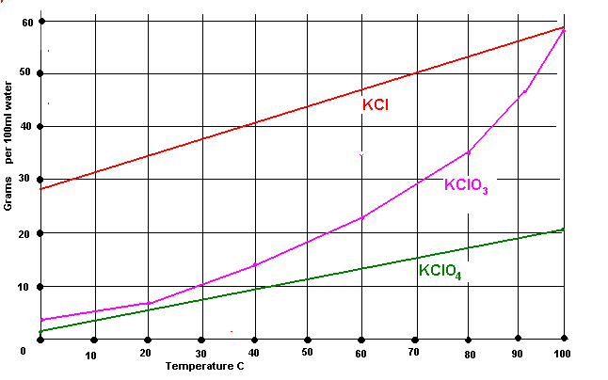
Graph above shows the solubility of some K Compounds.
See Solubility tables for a collection of data regarding solubilities of K Chlorate + K Chloride and K Chlorate + Na Chloride.
HIT THE BACK BUTTON ON YOUR BROWSER

